# **Fill Your Cup**

### I'm about to change your life.

Zoe's avatar

[Zoe](https://substack.com/@zoeffc)

Apr 25, 2025

3

[2](https://femmefuturescooperative.substack.com/p/fill-your-cup/comments)

1

Share

Hey you!

I’m changing lives today. Buckle up.

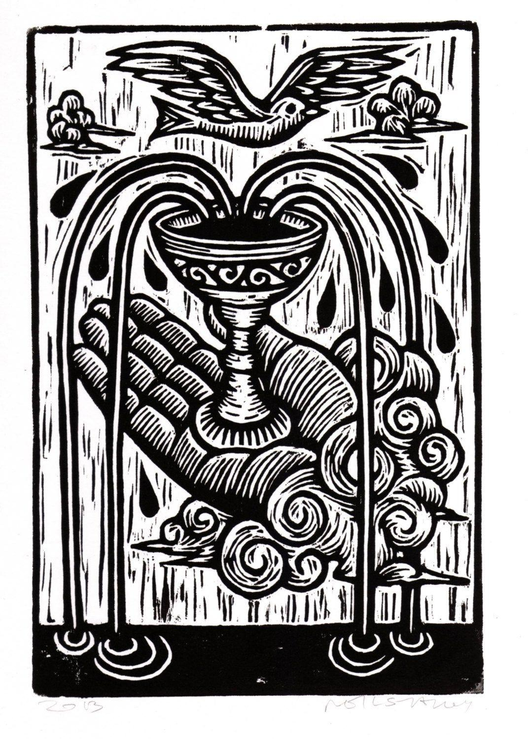

linocut by [Horse&Hare](https://horseandhareshop.com/products/tarot-card-linocut-art-print-ace-of-cups-tarot-card-woodcut-prints-home-decor-occult-art-anniversary-gift-housewarming-gift-1)

Before I go any further — let’s do the housekeeping.

First, if you are not already a subscriber and you resonate with any of the following descriptors, consider joining the cooperative: (1) Early-career professional; (2) Feminist; (3) Do-gooder; (4) Former Gifted Kid; (5) Overachiever; or (6) Capitalism-hater.

Subscribed

Second, if you like what I am saying and it makes you think of someone in your family/office/friend group, send it their way.

[Share Femme Futures Cooperative](https://femmefuturescooperative.substack.com/?utm_source=substack&utm_medium=email&utm_content=share&action=share)

Third, I say some personal and vulnerable shit every week. Say some vulnerable shit back. It’s called a community.

[Leave a comment](https://femmefuturescooperative.substack.com/p/fill-your-cup/comments)

Okay — back to it.

Last week, I offered some methods to help you in “filling your cup”. Today, we are talking about the metaphor because it changed my life.

*First, a very personal origin story of the phrase:*

It is no secret that I struggled severely with burnout as a result of toxic workplace dynamics and my own ambitious/perfectionistic tendencies. I have hit some lows in my professional life that I would give anything not to return to. That’s why I started the Femme Futures Cooperative — to provide honest perspective to people diving headfirst into a world that does not care how your mental health is doing (aka. capitalism).

When I started my current job, I was shaken and totally burnt out. This job was my best option to get out of a toxic situation and I leapt at it, knowing that it could be toxic, but hoping that it wasn’t. I got lucky. This new team cares about each other and are open to discussing mental health and taking active steps to ensure that we stay healthy, fulfilled, and productive.

In a meeting with this wonderful team of mine, one of my colleagues used this metaphor of “filling your cup” as a way to recognize what was energizing you and what was draining you. I won’t go into the semantics of the metaphor itself because it is a fairly common phrase that doesn’t take much brainpower to understand. We are the cup and energy is the stuff that we pour in or watch drain out.

When I was navigating the height of my burnout, I was reading everything that I could get my hands on to help me address it. None of what I read mentioned this idea. I am good at recognizing what task make me feel like the time is flying by and which tasks that make me feel like my brain is seeping out through my ears. The trick is balancing the two. *This* is the solution to burnout, at least the kind of burnout that I was experiencing.

*Here’s the practical bit:*

There are always going to be tasks that we must do that drain us. That is just an unfortunate fact of life. But there are also always going to be tasks that fill our cups. By being aware of which is which, we can use one as a salve for the other and maintain a sense of sanity.

Now, you are going to get stuck on this pretty quickly if you think that there is nothing in your job that feels fulfilling. First of all, I call bullshit. I could be wrong, but it would surprise me endlessly if you think that there is absolutely nothing that you do on an even somewhat regular basis that feels a little bit good. It can be something that you feel like no normal person would enjoy. I really like messing around with data or figuring out project timelines. Maybe your thing is putting on a podcast and doing data entry. I don’t know. It is up to you to find it.

Ok, so let’s say you’ve had a long day of exclusively draining tasks. You are exhausted, but you have thirty minutes to kill before you can reasonably walk away from your desk. Now is the time for you to pick a task that is exciting and will fill your cup. Or maybe it’s not a task, maybe it is a quick chat with a coworker or standing by a window and watching the leaves on the trees move.

You benefit by learning about yourself. You thrive by applying that knowledge of yourself to your lived experience.

Go forth and flourish.

Best,

Zoe